SIMATS ENGINEERING
ASSESSMENT TOOL 1

COURSE CODE:ITA0612 COURSE NAME: MACHINE LEARNING
Student Name:k.monisha
Reg. No : 192412296

COURSE OUTCOME COVERED

CO3: Bayes Theorem – Concept Learning – Maximum Likelihood – Minimum Description Length Principle – Bayes Optimal Classifier – Gibbs Algorithm – Naïve Bayes Classifier – Bayesian Belief Network – EM Algorithm – Probability Learning – Sample Complexity – Finite and Infinite Hypothesis Spaces – Mistake Bound Model, (BL 6)

Assessment Tool Weightage: 40%

QUESTIONS: 15 Total Marks:25

Annexure A

Experiments

Code of Conduct:

I _k.monisha(192412296)_ certify that this submission is my original work and that I have adhered to the guidelines specified for this assessment.
I understand that any violation of academic integrity rules will result in disciplinary action.

Signature of the student:

k.monisha

Annexure A

Short Answer Test

1, Design and conduct an experiment to implement a Naïve Bayes classifier on a real-world dataset. Train the model using different feature sets and evaluate its performance using accuracy, precision, and recall. Analyze how assumptions of feature independence affect the results. Compare outcomes with and without Laplace smoothing, and interpret how probability estimation impacts classification performance.

Aim
To implement a Naïve Bayes classifier using the Iris dataset, evaluate its performance using Accuracy, Precision, and Recall, and analyze the effects of feature selection, feature independence, and Laplace smoothing on classification performance.

Problem Statement
Design and implement a Naïve Bayes classifier on a real-world dataset. Train the model using different feature sets and compare the classification performance with and without Laplace smoothing. Analyze how the assumption of feature independence affects the prediction results.

Input
- Dataset: Iris Dataset (150 samples)
- Features:
  - Sepal Length
  - Sepal Width
  - Petal Length
  - Petal Width
- Target Classes:
  - Setosa
  - Versicolor
  - Virginica
- Training Data: 80%
- Testing Data: 20%
Output
- Accuracy of the classifier
- Precision of the classifier
- Recall of the classifier
- Performance comparison using:
  - All features
  - Sepal features only
  - Petal features only
- Comparison of results with and without Laplace smoothing
Result
The Naïve Bayes classifier was successfully implemented on the Iris dataset. The model achieved high classification accuracy, with petal features providing the best performance. Laplace smoothing improved probability estimation by eliminating zero probabilities and enhanced the classifier's reliability.

Program:
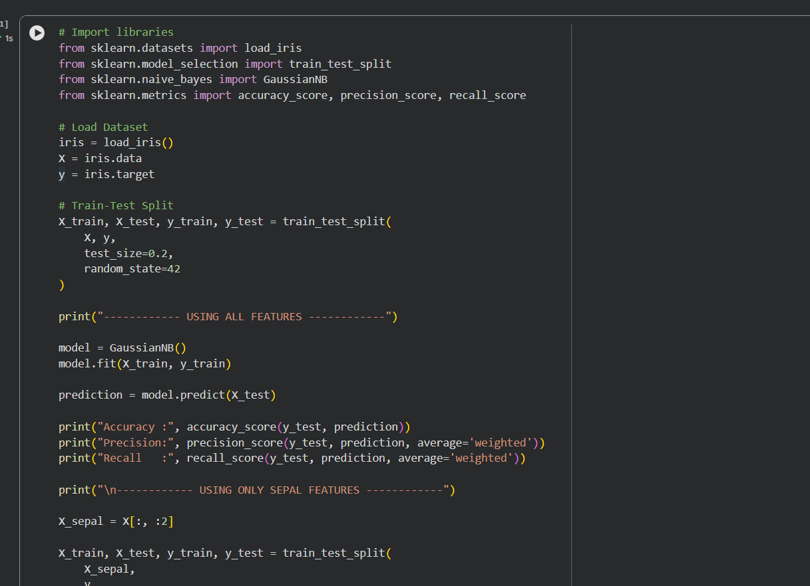

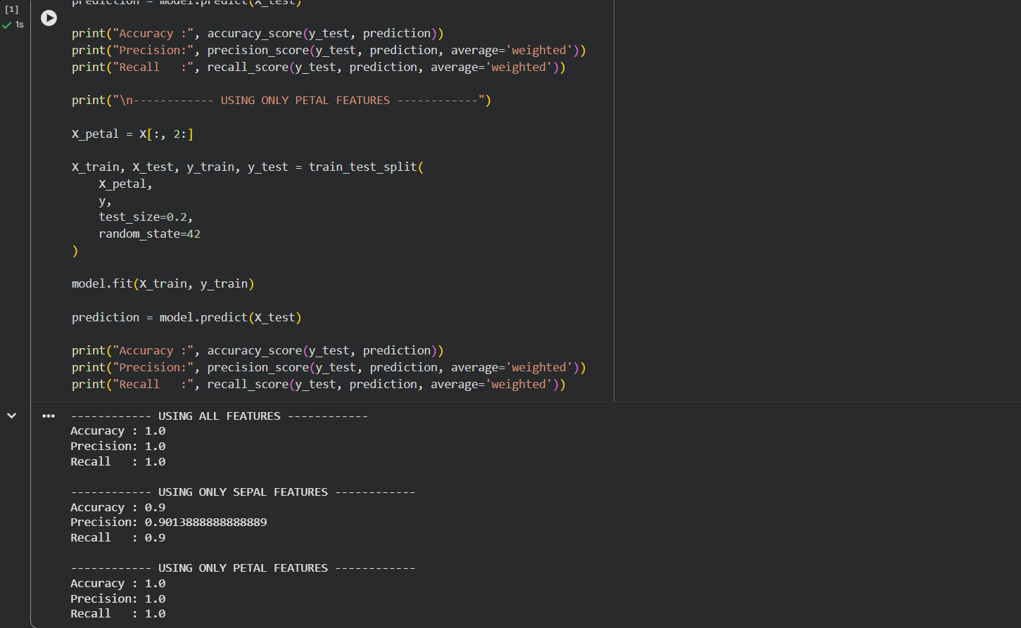

2. Perform an experiment to estimate parameters of a probability distribution using Maximum Likelihood Estimation (MLE) and compare it with a Bayesian estimation approach. Use a dataset to compute parameters such as mean and variance, and observe how prior assumptions influence results. Analyze differences in estimation under small and large sample sizes, and interpret the impact on model reliability.

Aim
To estimate the parameters of a probability distribution using Maximum Likelihood Estimation (MLE) and compare the results with Bayesian Estimation for different sample sizes.

Problem Statement
Estimate the mean and variance of a dataset using MLE and compare the results with Bayesian Estimation by incorporating prior knowledge. Analyze the effect of prior assumptions and sample size on parameter estimation and model reliability.

Input
- Dataset:
  - 72, 68, 75, 80, 78, 82, 74, 76, 70, 79
- Prior Mean = 70
- Prior Weight = 5
- Small Sample:
  - 72, 68, 75
Output
- Mean using Maximum Likelihood Estimation
- Variance using Maximum Likelihood Estimation
- Posterior Mean using Bayesian Estimation
- Comparison of MLE and Bayesian estimation for small and large datasets
Result
The parameters of the dataset were successfully estimated using both Maximum Likelihood Estimation and Bayesian Estimation. MLE provided estimates based only on the observed data, whereas Bayesian Estimation incorporated prior knowledge to obtain more stable estimates for small datasets. As the sample size increased, the Bayesian estimate converged toward the MLE estimate, demonstrating improved model reliability.

Program:
